**I have Created 4 Tables in database dbn**

1. Login

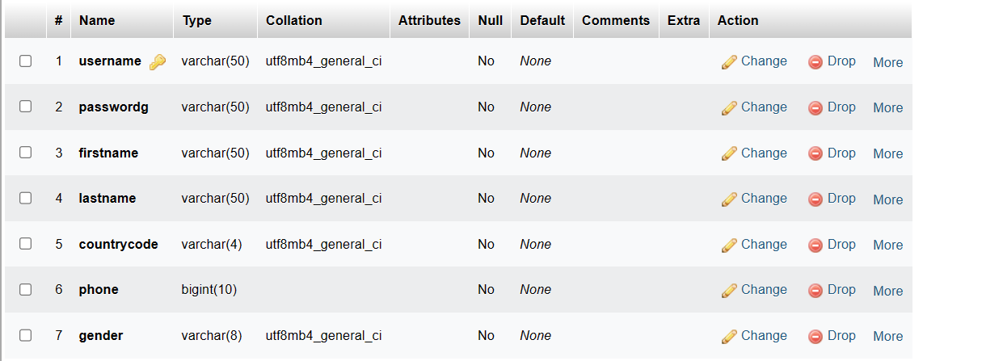

1. Propage (product table)

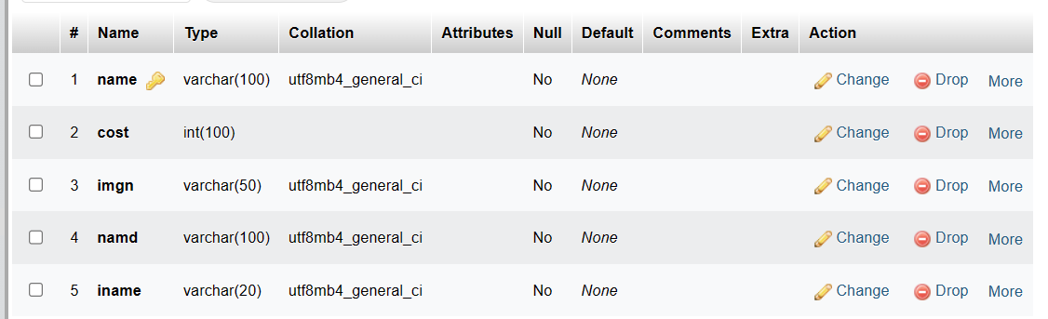

Example:

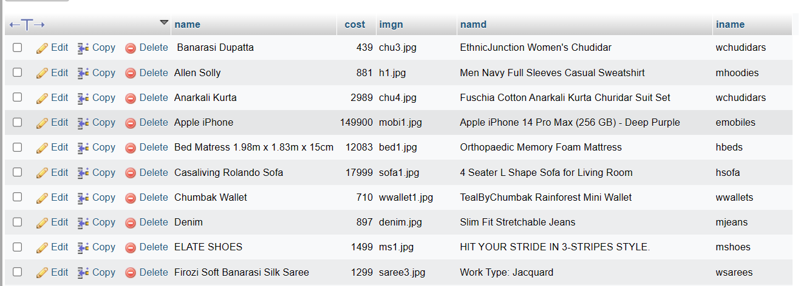

1. cart

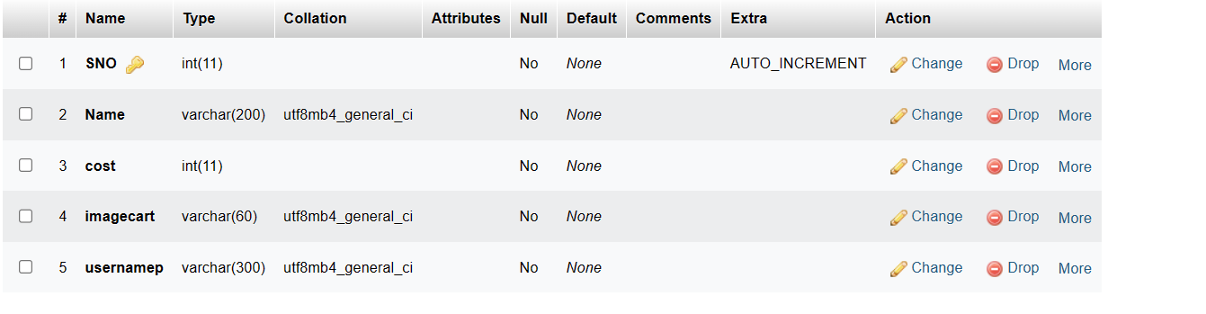

1. history

